- Git Setup https://confluence.atlassian.com/bitbucket/set-up-git-744723531.html

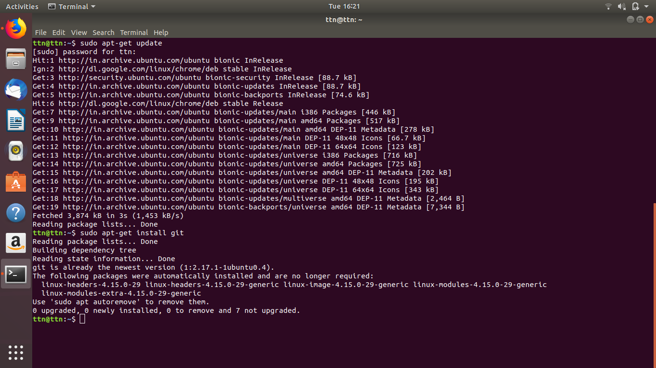
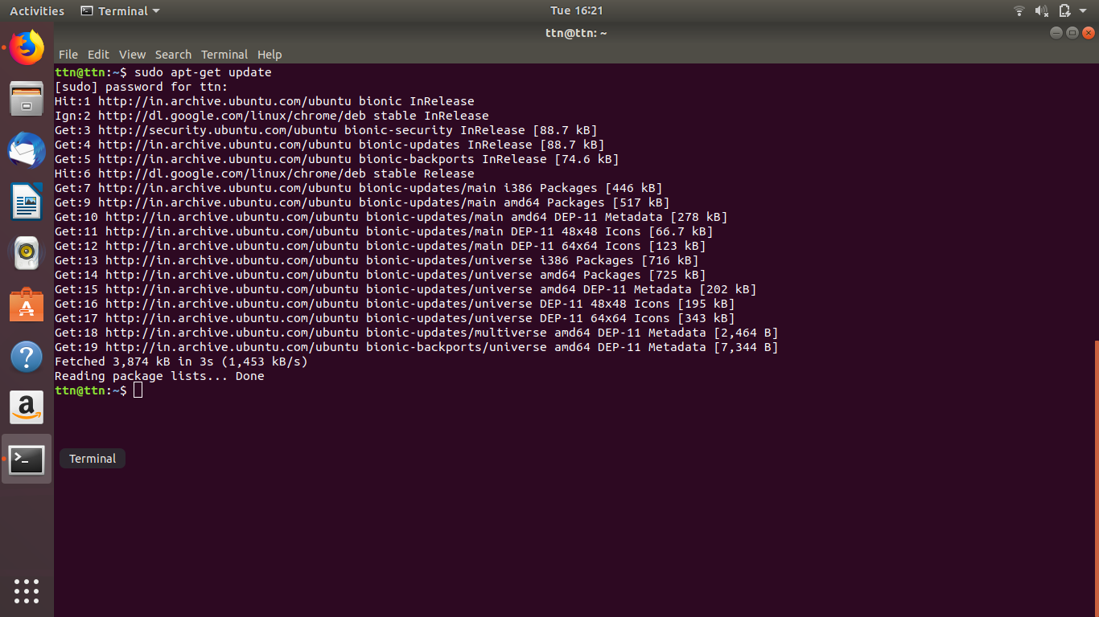
- Initialize a Git Repository

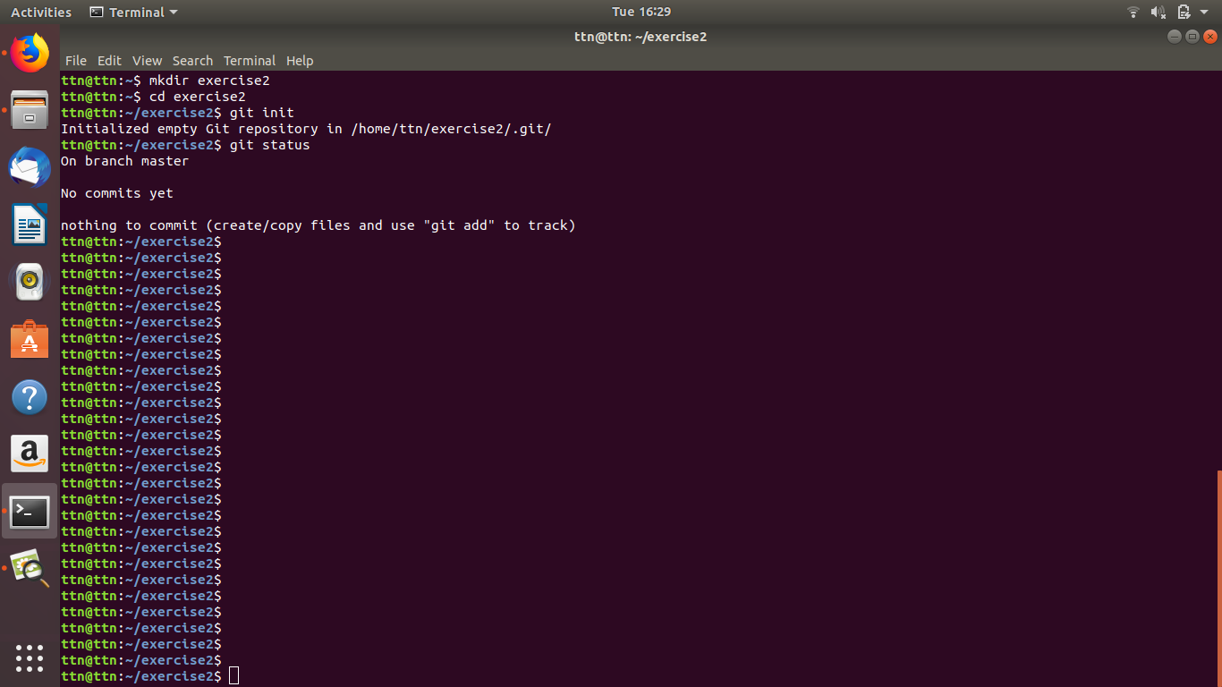

- Add files to the repository

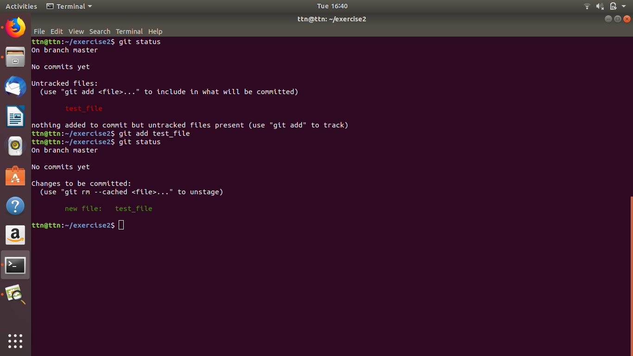

- Unstage 1 file

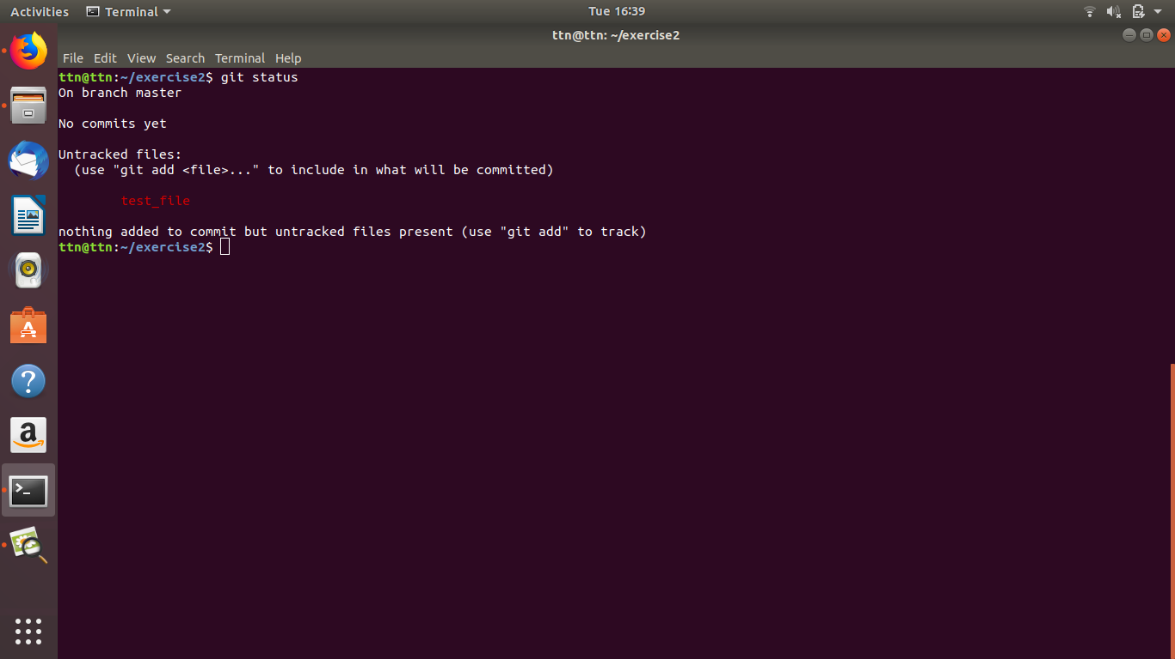

- Commit the file

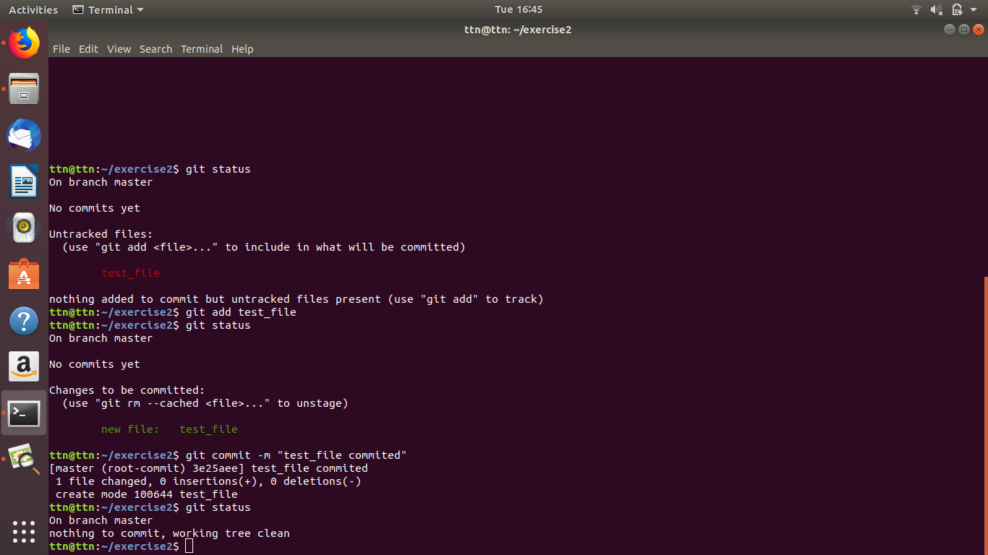

- Add a remote

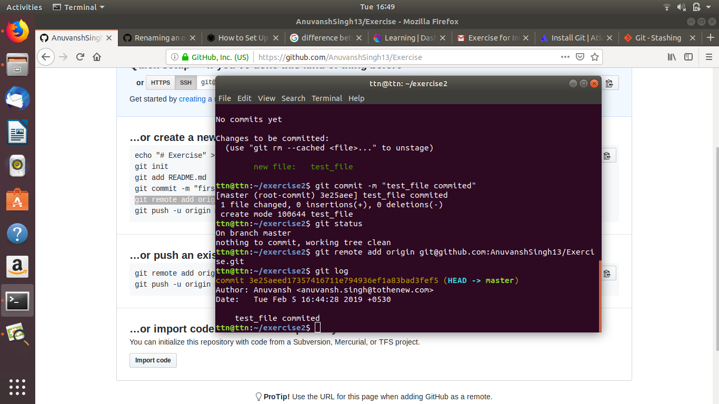

- Undo changes to a particular file

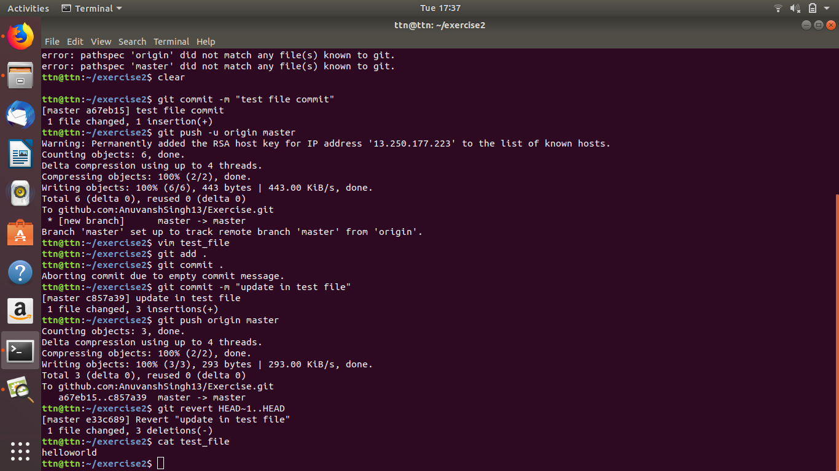

- Push changes to Github

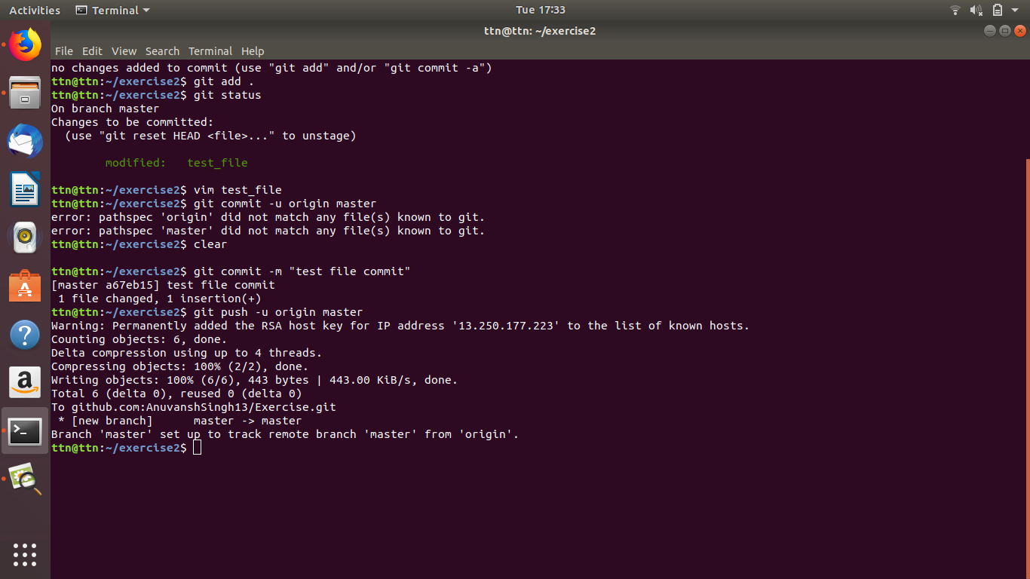

- Clone the repository

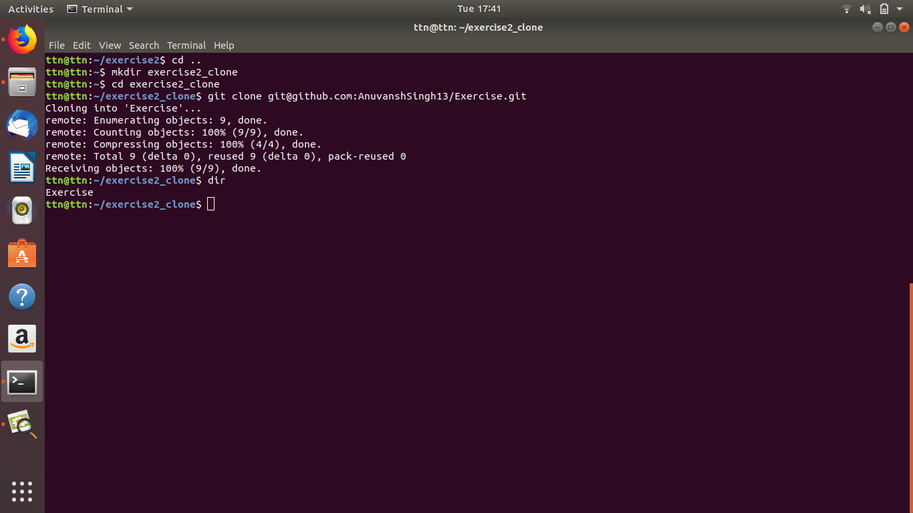

- Add changes to one of the copies and pull the changes in the other.

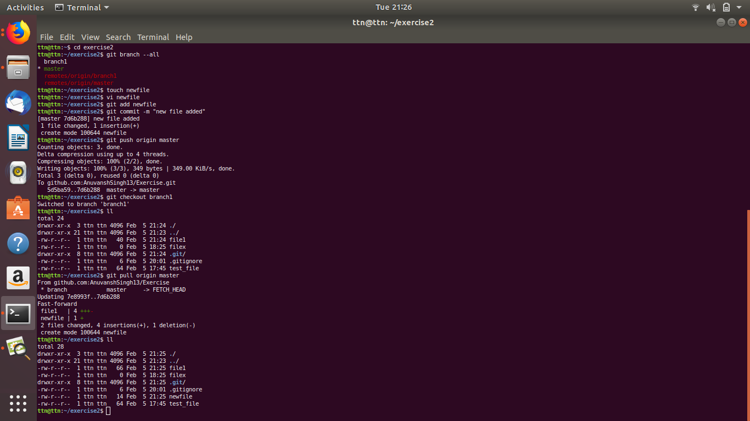
- Check differences between a file and its staged version

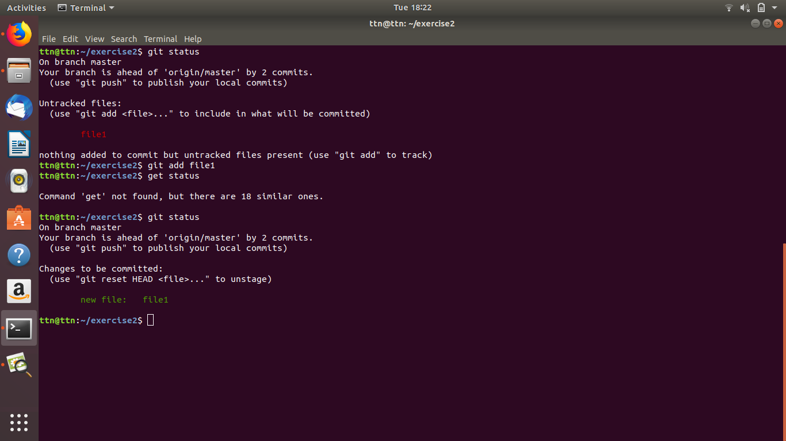

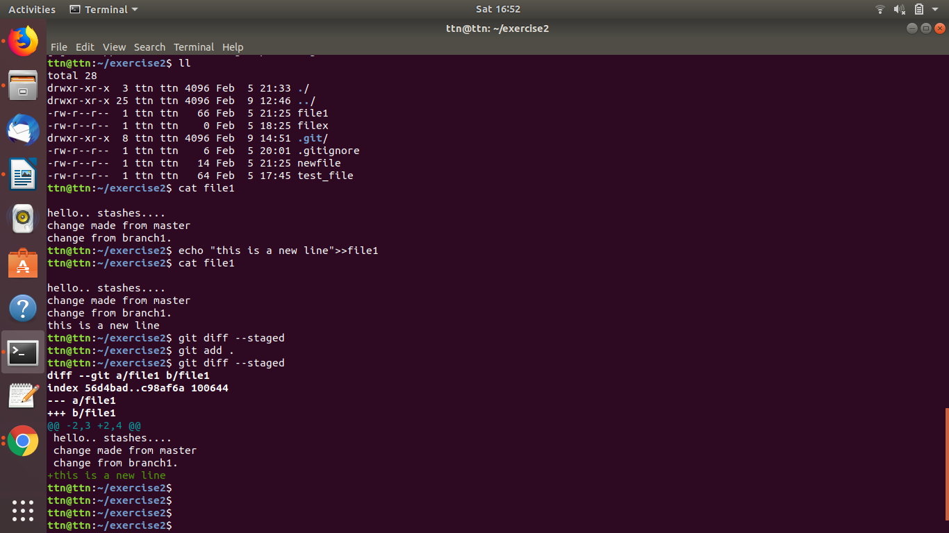

- Ignore a few files to be checked in

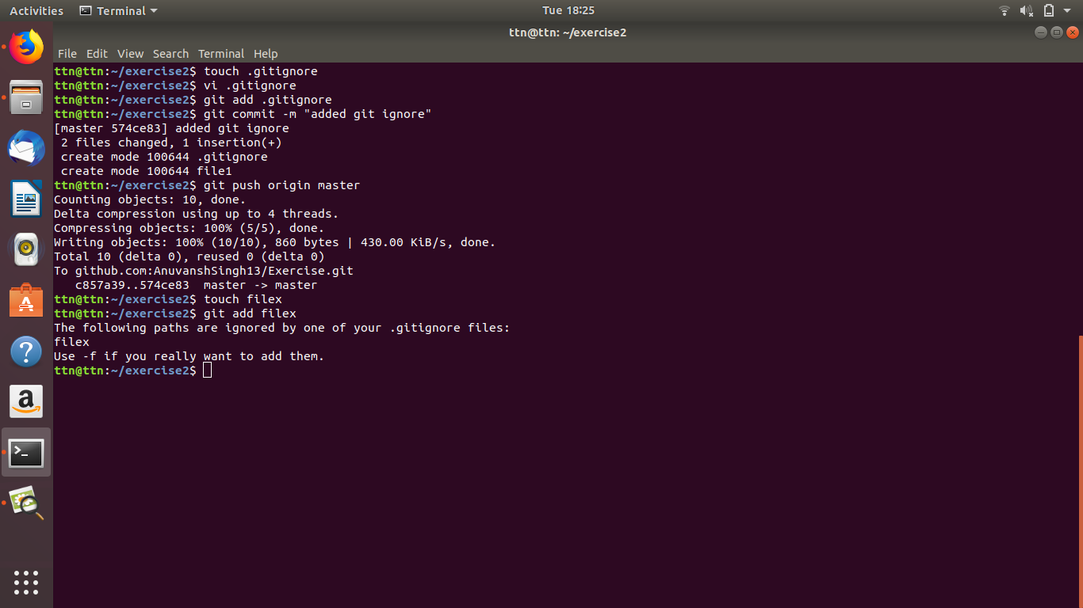

- Create a new branch.
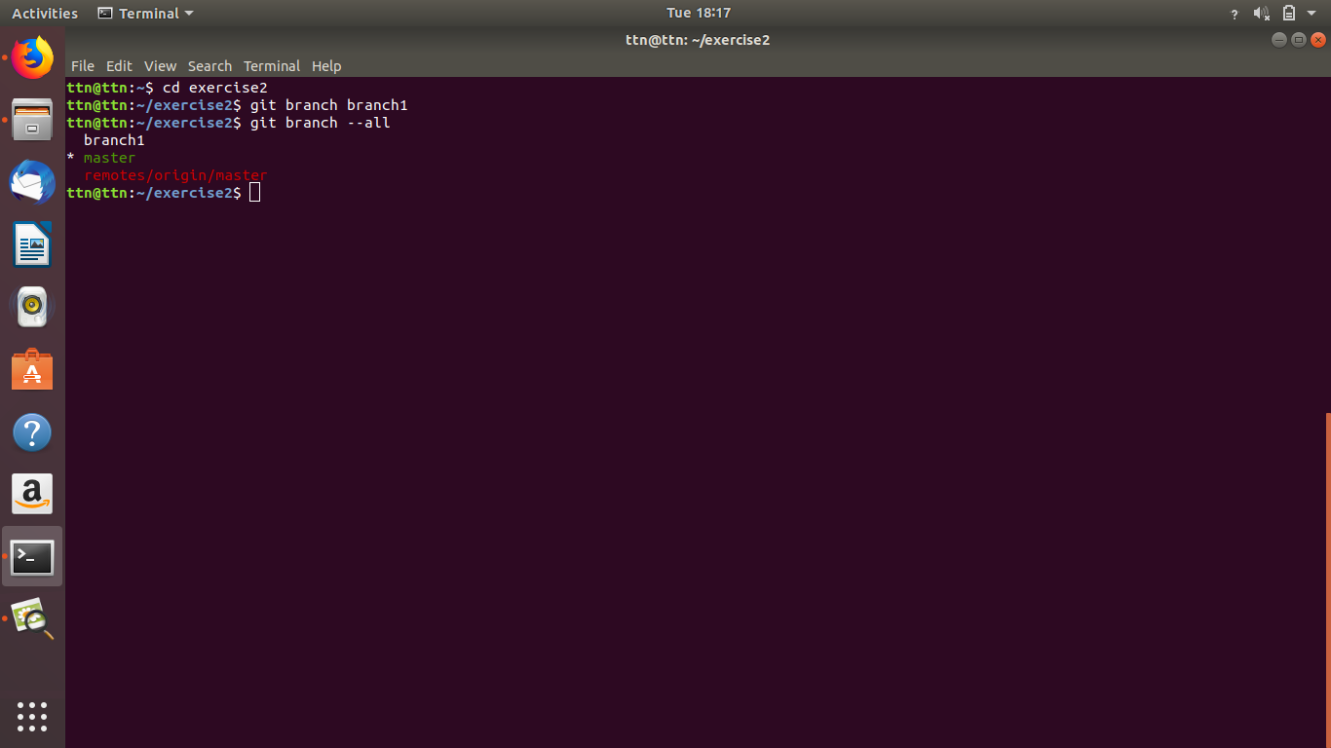

- Diverge them with commits

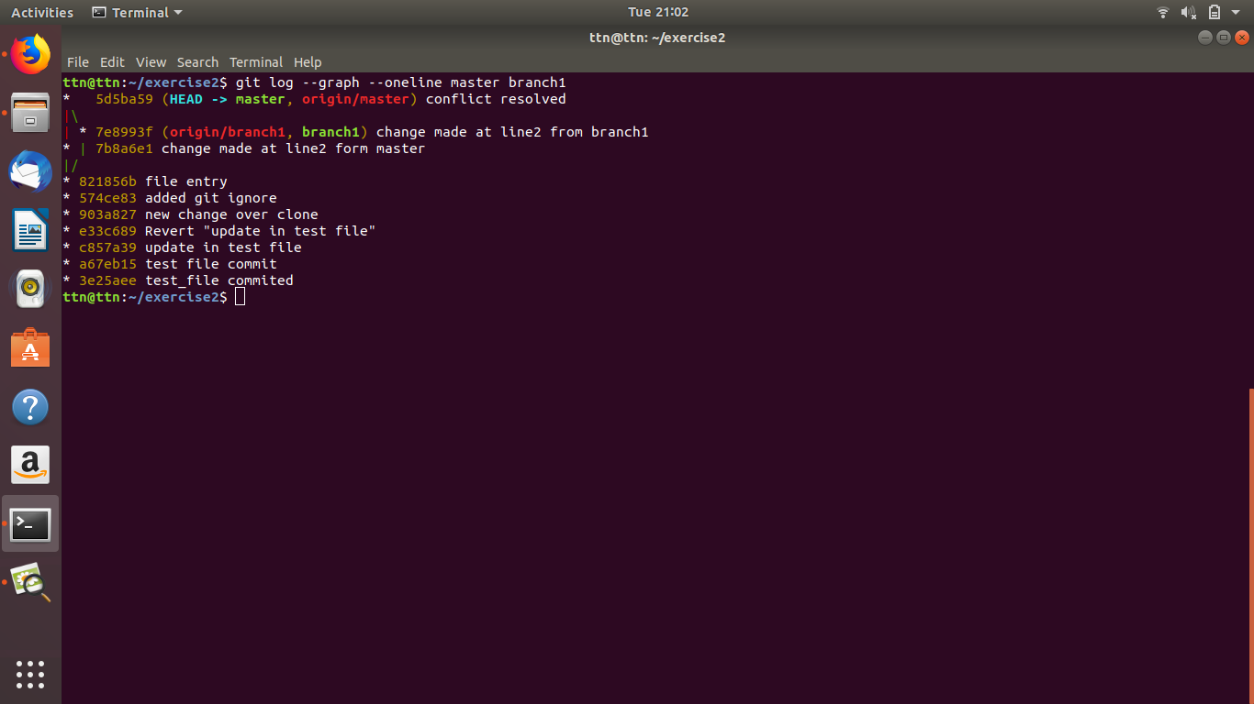

- Edit the same file at the same line on both branches and commit

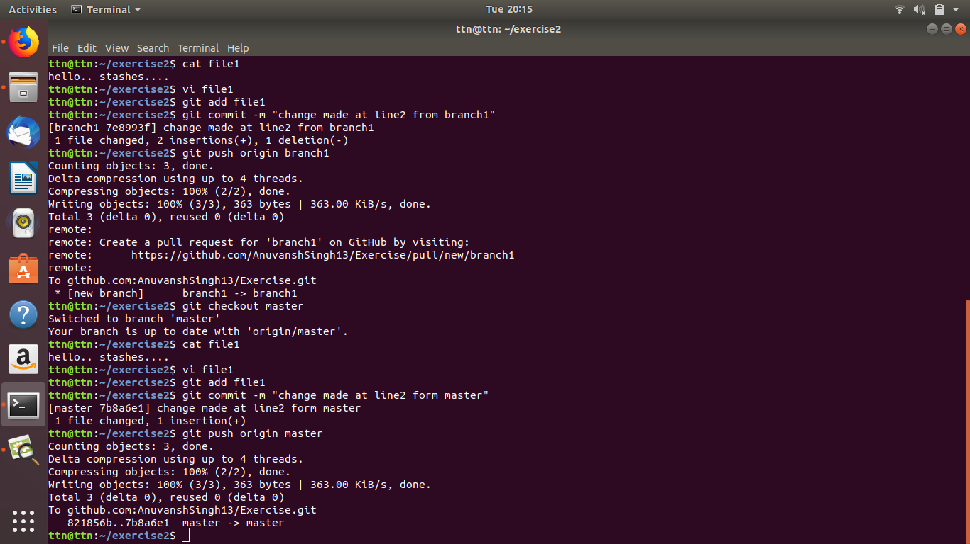

- Try merging and resolve merge conflicts

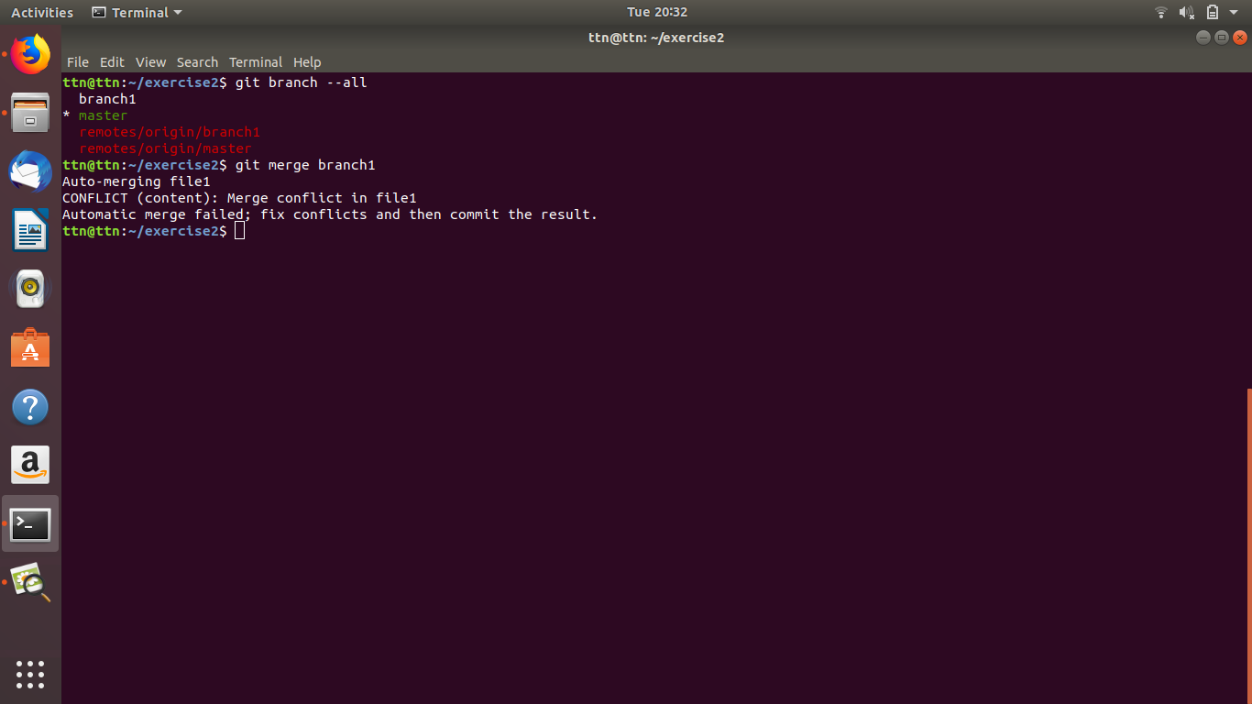
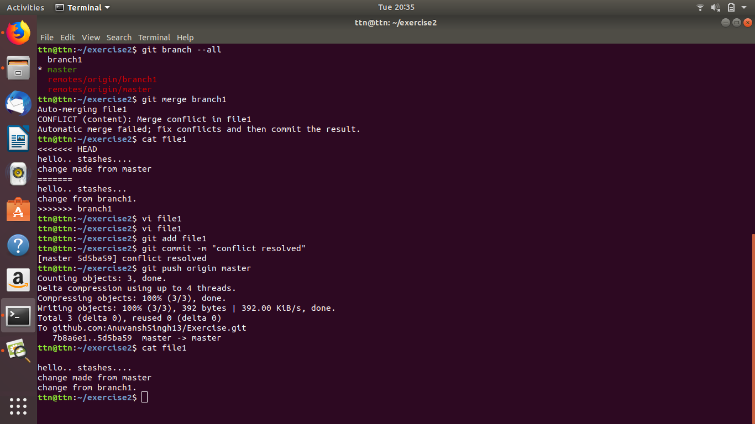
- Stash the changes and pop them

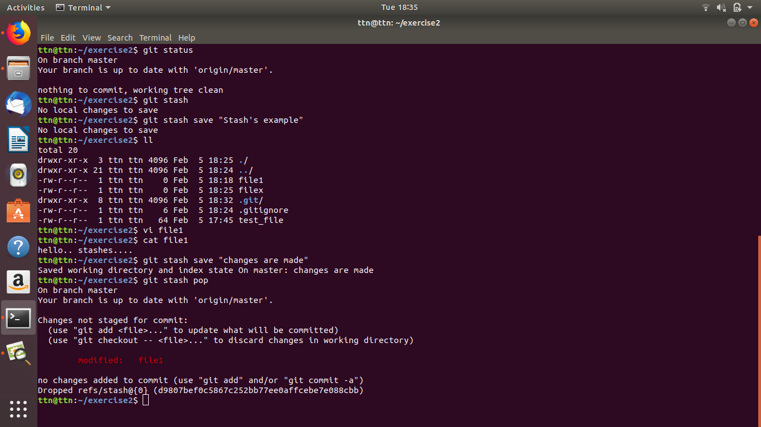

- Add the following code to your .bashrc file : color_prompt="yes"
parse_git_branch() {
git branch 2> /dev/null | sed -e '/^[^*]/d' -e 's/* \(.*\)/(\1)/'
}
if [ "$color_prompt" = yes ]; then
PS1='\u@\h\[\033[00m\]:\[\033[01;34m\]\W\[\033[01;31m\] $(parse_git_branch)\[\033[00m\]\$ '
else
PS1='\u@\h:\W $(parse_git_branch)\$ '
fi
unset color_prompt force_color_prompt
